Let's Meet

Group ID: 05

3005 – Jaishil Bhavsar

3036 – Zeel Modi

3186 – Bhargavi Jansari

**Index**

**Chapter 3: System Management and Planning1**

3.1 Feasibility Study2

3.1.1 Technical

3.1.2 Economic

3.1.3 Operational

3.2 Hardware – Software Requirement5

3.3 System Planning6

3.3.1 Work Breakdown Structure

3.1.1 Gantt Chart

3.4 Process Model8

# [**3.1**]Feasibility Study

A feasibility study is carried out to select the best system that meets performance requirements.

The main aim of the feasibility study activity is to determine whether it would be financially and technically feasible to develop the product. The feasibility study activity involves the analysis of the problem and collection of all relevant information relating to the product such as the different data items which would be input to the system, the processing required to be carried out on these data, the output data required to be produced by the system as well as various constraints on the behaviour of the system.

* + 1. **Technical Feasibility:**

This is concerned with specifying the equipments and the software to satisfy the user requirements. The technical needs of the system vary considerably but might include:

* The facility to produce outputs in a given time.
* Response time under certain conditions.
* Ability to process a certain volume of transactions at a specified speed.
* Facility to communicate data to a distant location.

Technical feasibility centres on the existing computer system, hardware, software etcetera and to what extent it can support the system. In examining the technical feasibility, the configuration of the system is given more importance than the actual hardware.

Our system can be run on any mobile platform including Android, iOS and Windows. So that we can easily say that our system is technically feasible.

* + 1. **Economic Feasibility:**

Economic analysis is the most frequently used technique for evaluating the effectiveness of a proposed system. More commonly known as Cost / Benefit analysis, the procedure is to determine the benefits and savings that are expected from a proposed system and compare them with costs. The system is economical feasible because:

* There is no extra economical cost because system is develop with an open source technology.
* Our system is not much costly to develop.
* Organisation is ready to invest in proposed system because it is being developed in latest technology.
  + 1. **Operational Feasibility:**

Operational feasibility study tests the operational scope of the software to be developed. The proposed software must have high operational feasibility. The usability will be high.

Operation of the proposed system depend on its various users.

Various user-types of Users are mentioned below:

1. Admin:

Admin will authenticate events and users. If any of these are invalid admin have rights to remove them from using system. Admin can make any change at a time.

1. Normal User:

Users will be able to do sign-up, login, feedback any event. Interface of the system is so easy that users don’t have to go anywhere for training.

# [**3.2**]Hardware – Software Requirement

Hardware:

* RAM : 512 MB
* ROM : 100-150 MB (MAX)

Software:

* Front-End : Ionic,Angular,Php
* Back-End: MySql,NodeJs,Php
* Database : MySql
* Tools : Visual Studio Code

# [**3.3**]System Planning

# [**3.3.1**]Work Breakdown Structure

# [**3.3.2**]Gantt Chart

|  |  |  |  |  |  |
| --- | --- | --- | --- | --- | --- |
| Activities | July | Aug | Sept | Oct | Nov |
| 1. Project Management |  |  |  |  |  |
| * Start of Project |  |  |  |  |  |
| 1. Definition |  |  |  |  |  |
| * Analyze requirements |  |  |  |  |  |
| * Conduct Feasibility Study |  |  |  |  |  |
| * Preliminary Project Plan and Project Proposal |  |  |  |  |  |
| * Project Plan Complete |  |  |  |  |  |
| 1. Analysis |  |  |  |  |  |
| * Prepare Functional Specification Document |  |  |  |  |  |
| * Functional Specific Review |  |  |  |  |  |
| * Functional Specification Complete |  |  |  |  |  |
| * Revised Project Plan |  |  |  |  |  |
| 1. Design |  |  |  |  |  |
| * Prepare Design Specification Document |  |  |  |  |  |
| * Design Review |  |  |  |  |  |
| * Revise Documents |  |  |  |  |  |
| * Setup Development Environment |  |  |  |  |  |
| * Design Process Complete |  |  |  |  |  |

# [**3.4**]Process Model

A software process model is a standardised format for

• planning

• organising, and

• running

a development project. A software life cycle model is either a descriptive or prescriptive characterization of how software is or should be developed.

**What is Incremental Model?**

Incremental Model is combination of one or more Waterfall Model. In Incremental Model, Project requirements are divided into multiple modules and each module is developed separately. Finally developed modules are integrated with other modules. During development of each module, Waterfall Model is followed for each module development separately. Each developed module in Incremental Model is standalone feature and could be delivered to the end users to use it. On incremental basis other modules are integrated as additional features one after another and finally delivered to the client. In Incremental Model no need to wait for all the modules to be developed and integrated. As each module is standalone application and there is no dependencies on other modules so we can deliver the project with initial developed feature and other features could be added on incremental basis with new releases. Incremental process goes until all the requirements fulfilled and whole system gets developed.

[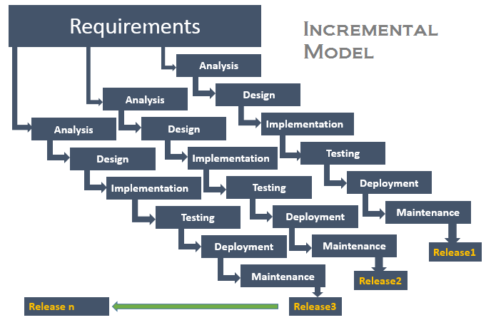](http://testingfreak.com/wp-content/uploads/2015/02/incremental.png)

Incremental Model helps to deliver the sequence of releases in incremental basis which speeds up the progress of development of each functionality. Each developed functionality gets delivered to the end users one after another. First increment is always a base feature and other features added in next increments with new releases in case client requests to add the any new feature after review of first release. This process is carried out till the complete product is developed.

**Why to Use Incremental Model?**

* It is flexible and less costly to change scope and requirements.
* Generates working software quickly and early during the software life cycle.
* Each iteration is easily managed milestone.
* We can get our customer responded and can change according to their requirements. Rather than other model here customers have exact idea about their proposed system. In other models customers get their system at last so we can’t know whether our customer is satisfied or not. Here we’re constantly in touch with customer. This model provides higher customer satisfaction